Transaction Code: ZFIBRS
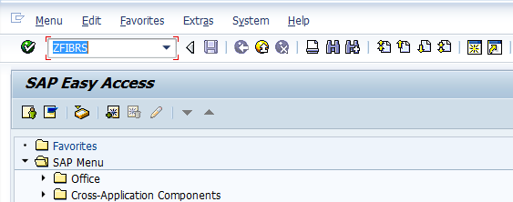
- Input ZFIBRS in Transaction box and press Enter Key
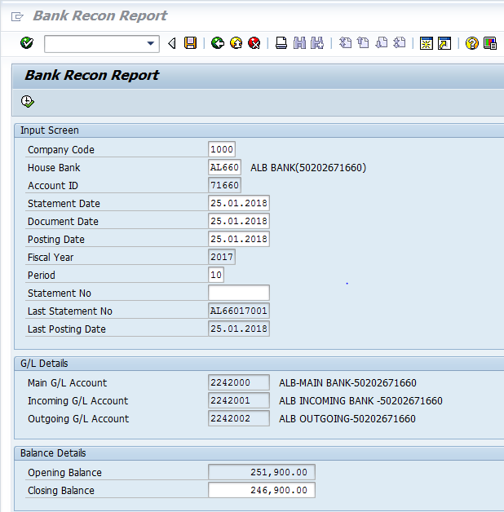

The following are the Input fields in the Bank Reconciliation Report
Data in Input Section:
- Company code: Input the Company code 1000
- House Bank: Select the relevant house bank with help of “F4” key, House bank to be reconciled
- Account ID: Respected Account ID would be fetched automatically.
- Fiscal Year: Input the Fiscal year of the company code
- Statement Date: Input the Statement Date as on which date statement is received from bank, on it can be reconciliation date.
- Document Date: Input document date as reconciliation current date
- Posting Date: Input reconciliation posting date.
- Statement No: system will generate the statement number automatically on statement posting.
Input Data for GL Details Section:
- GL Accounts: all the GLs number (Main/Outgoing/Incoming) related house bank would be fetched automatically as configured with house bank.
Input Data for Balance Details section:
- Opening Balance: Opening as closing of last statement would be fetched automatically.
- Closing Balance: Input manually closing balance of bank statement as on dated reconciliation to be done.
- Click on Execute Button
- System will display the information of Debit and Credit line items of the respective House Bank

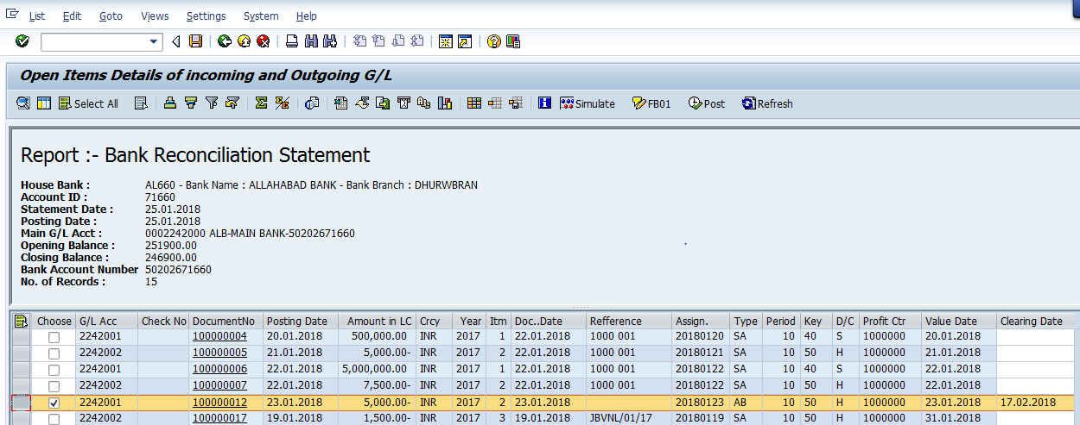

- Select the lines which have already been cleared into bank.
- Input the clearance date as on which date amount is created / debited in bank Statement.

- Simulate the same transactions.

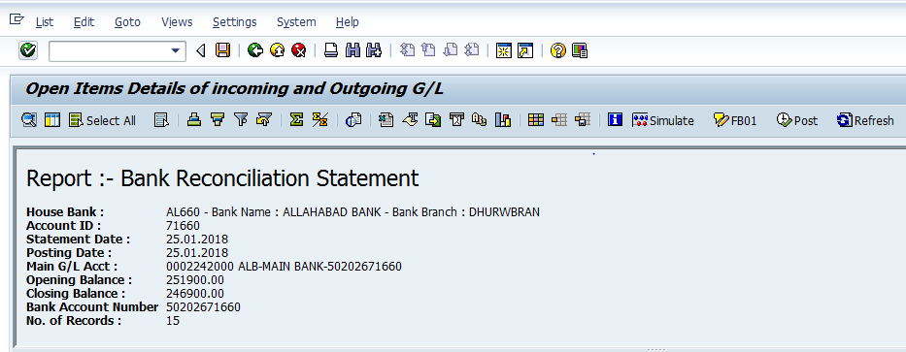

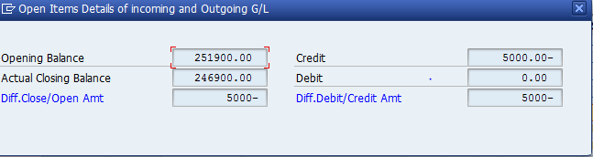

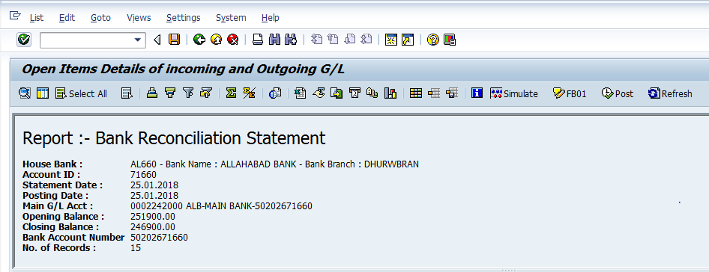
- Click on Post option in the Standard tool Bar
- System will pop up the message box showing the document numbers which was posted successfully.
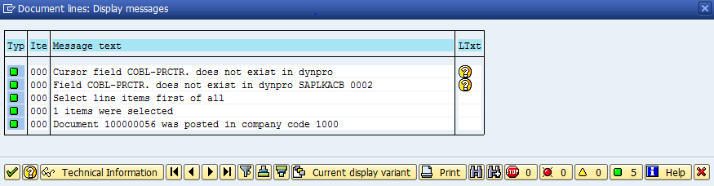
- Clicking on Ok button system will generate the Statement Number successfully
Display View:
Display view of the posted documents
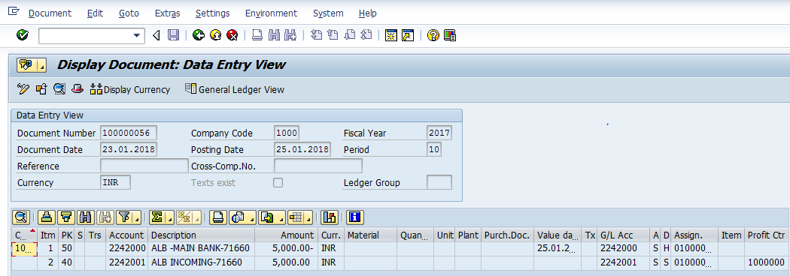

Process End

